Laboratory report number 10
Nurzhanov Amirkhan
Task 1
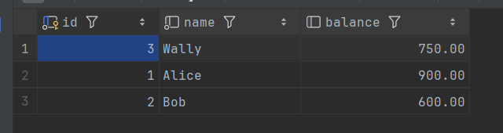
a) Alice's balance will be 900, Bob's will be 600
b) To keep the principle of Atomicity, either whole statement is to be done or none. Since it's a money transfer operation
c) Alice would have lost her 100 dollars as Bob wouldn't have received it
Task 2
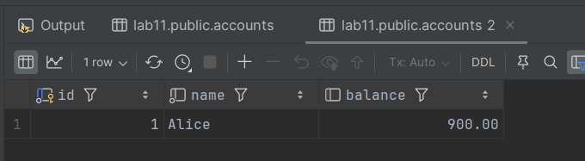a) Alice's balance was 400
b) 900
c) To undo the mistaken transaction. For example: undo the money transfer operation to the other user.
Task 3
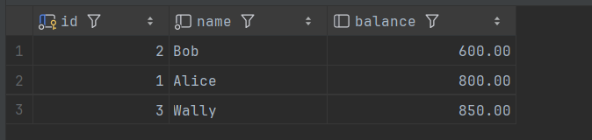
a) Alice's balance will remain at 800, Bob's will be 600, Wally's will be 850*
b) Yes, Bob’s account was temporarily credited after the second UPDATE, but the ROLLBACK undid that change before COMMIT
c) It allows partial rollback within a single transaction, preserving earlier valid work without needing to restart the entire transaction
Task 4
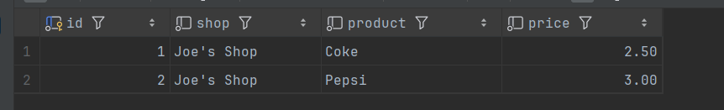

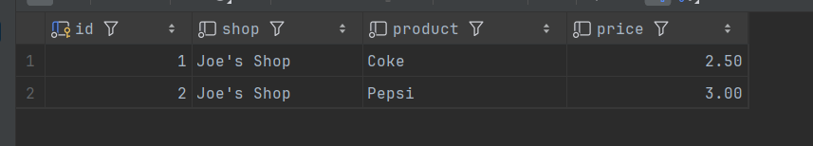 - SERIALIZABLE
a) It sees original products Coke and Pepsi. But after Terminal 2 commits, it sees only Fanta.
b) It sees the same data in both SELECTs (Coke, Pepsi), because SERIALIZABLE isolation prevents seeing changes made by other transactions until terminal 1 itself commits.
c) READ COMMITTED: Allows non-repeatable reads; a transaction sees committed changes from other transactions immediately.
SERIALIZABLE: Prevents all concurrency anomalies; transactions are fully isolated as if executed sequentially.
Task 5


a) No, because REPEATABLE READ prevents seeing new rows inserted after the first read (phantom rows).
b) A phantom read occurs when a transaction re-executes a query and sees new rows that were inserted by another committed transaction.
c) SERIALIZABLE prevents phantom reads.
Task 6
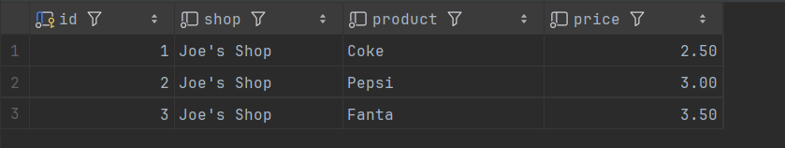

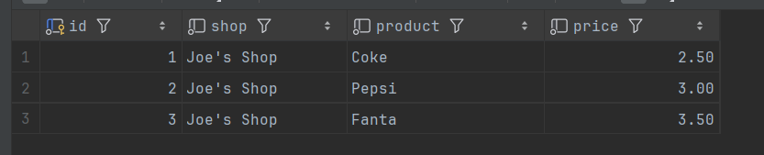
- Theoretically, it should have seen the price of 99.99 but Postgresql prevents dirty data reads. Aside that, this is problematic because Terminal 2 never committed that change - it rolled back. Terminal 1 made decisions based on data that never actually existed in the database.
- A dirty read occurs when a transaction reads data that has been modified by another transaction but not yet committed. If the other transaction rolls back, the first transaction has read "dirty" (invalid) data.
- Because it breaks consistency - applications can make incorrect decisions based on uncommitted, potentially invalid data.

Independent exercises
Exercise 1
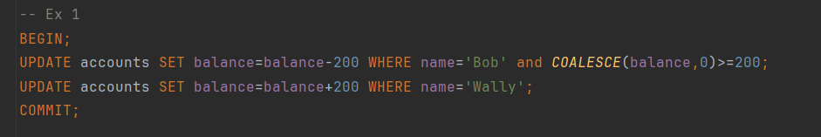
Exercise 2
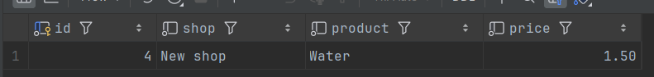
BEGIN;
INSERT INTO products(shop,product, price)
VALUEs( 'New shop','Water', 1.50);
SAVEPOINT new_product_savepoint;
SELECT * FROM products WHERE shop='New shop';

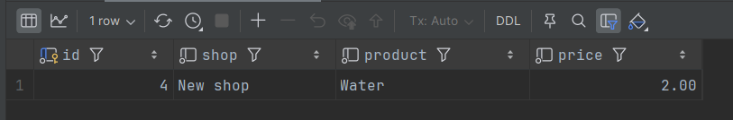
UPDATE products SET price = 2.00 WHERE product = 'Water';
SAVEPOINT update_price_savepoint;
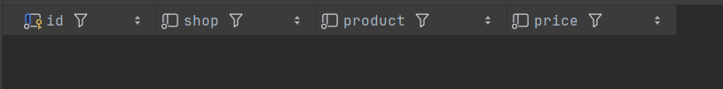
DELETE FROM products WHERE product='Water';
ROLLBACK TO new_product_savepoint;
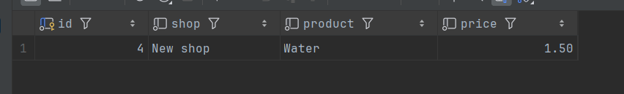
COMMIT;
Exercise 3
 - 1 console
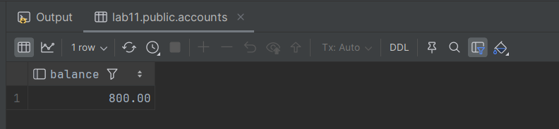- 2 console
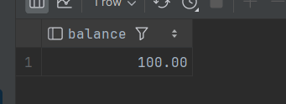 - 2 console, after console 1 committed and update statement in second was done

-- Session 1 (User A)
BEGIN TRANSACTION ISOLATION LEVEL READ COMMITTED;
SELECT balance FROM accounts WHERE name = 'Alice';
-- Balance 800
UPDATE accounts SET balance = balance - 300 WHERE name = 'Alice';
-- Do not commit yet
COMMIT;

-- Session 2 (User B)
BEGIN TRANSACTION ISOLATION LEVEL READ COMMITTED;
SELECT balance FROM accounts WHERE name = 'Alice';
-- Still sees 800 (if User A hasn't committed)
UPDATE accounts SET balance = balance - 400 WHERE name = 'Alice';
-- This will wait if User A hasn't committed (row lock)

- READ COMMITTED: Second transaction sees first update only after commit. Essentially, the user B will only see committed data of the user A, but not the same data at each time. May cause lost update if not careful.

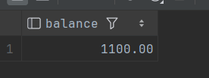 in console 1 after update statements without committing (with SERIALIZABLE transaction).
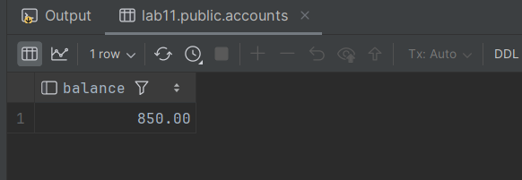 in console 2. 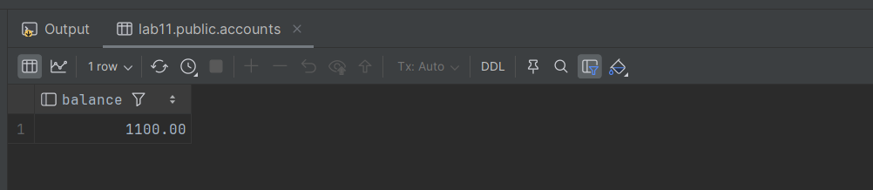
In console 2 after console 1 committed the transaction.
-- Session 1
BEGIN TRANSACTION ISOLATION LEVEL SERIALIZABLE ;
SELECT balance FROM accounts WHERE name = 'Wally';
-- Balance 850
UPDATE accounts SET balance = balance - 300 WHERE name = 'Wally';
UPDATE accounts SET balance=balance*2 WHERE name='Wally';
-- Balance 1100
-- Do not commit yet
COMMIT;

-- Session 2
BEGIN;
SELECT balance FROM accounts WHERE name = 'Wally';

- REPEATABLE READ/SERIALIZABLE: The second session will only see the updated data after the first transaction is fully committed in the first session. It will see the database either before or after session 1 commits the transaction, but not in the middle. Might abort one transaction with serialization error if concurrent modifications detected (money transferring at the same time from the same account).

Exercise 4
Sally queries:
BEGIN;
SELECT MIN(price), MAX(price) FROM products WHERE shop = 'Joe''s Shop'; (min: 2.50, max: 3.00)

Joe updates:
BEGIN;
DELETE FROM products WHERE product='Pepsi';
INSERT INTO products(shop,product,price) VALUES ('Joe''s shop','water',1.00);
COMMIT;
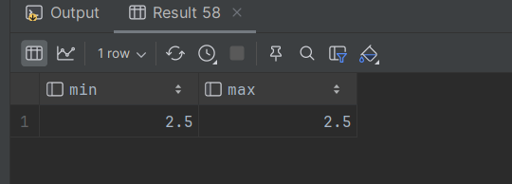
Fix

BEGIN TRANSACTION ISOLATION LEVEL SERIALIZABLE;
SELECT MAX(price) FROM products
WHERE shop = 'Joe''s Shop';

BEGIN;
DELETE FROM products
WHERE shop = 'Joe''s Shop' AND price = 3.00;
INSERT INTO products (shop, product, price)
VALUES ('Joe''s Shop', 'water', 1.00);
COMMIT;
Joe will either be blocked until Sally finishes or get a serialization error.

SELECT MIN(price) FROM products
WHERE shop = 'Joe''s Shop';

COMMIT;

Questions
- Atomicity
Either the whole process is done or none is.
Example: Transferring $100 from Alice to Bob: either Alice loses $100 and Bob gains $100, or neither happens.
Consistency
Database constraints are preserved.
Example: An account balance cannot become negative if there is a constraint preventing it.
Isolation
It appears to the user as if only one process executes at a time.
Example: If Joe is updating prices, Sally can’t see those updates until Joe commits.
Durability
Effects of a process do not get lost if the system crashes.
Example: After COMMIT, the money transfer still exists after a power failure.
- COMMIT permanently saves all changes made in the transaction.
ROLLBACK cancels all changes made in the transaction and returns the database to the last committed state.

